1. wget https://nginx.org/download/nginx-1.15.7.tar.gz && tar zxvf nginx-1.15.7.tar.gz

wget https://ftp.pcre.org/pub/pcre/pcre-8.42.tar.gz && tar xzvf pcre-8.42.tar.gz

wget https://www.zlib.net/zlib-1.2.11.tar.gz && tar xzvf zlib-1.2.11.tar.gz

wget https://www.openssl.org/source/openssl-1.1.1a.tar.gz && tar xzvf openssl-1.1.1a.tar.gz

wget <https://codeload.github.com/openresty/headers-more-nginx-module/tar.gz/v0.33>

1. mv v0.33 v0.33.tar

tar -xvf v0.33.tar

1. sudo yum install -y perl perl-devel perl-ExtUtils-Embed libxslt libxslt-devel libxml2 libxml2-devel gd gd-devel GeoIP GeoIP-devel
2. ./configure --prefix=/opt/nginx_install \

--user=nginx \

--group=nginx \

--build=CentOS \

--builddir=nginx-1.15.7 \

--with-select_module \

--with-poll_module \

--with-threads \

--with-file-aio \

--with-http_ssl_module \

--with-http_v2_module \

--with-http_realip_module \

--with-http_addition_module \

--with-http_xslt_module=dynamic \

--with-http_image_filter_module=dynamic \

--with-http_geoip_module=dynamic \

--with-http_sub_module \

--with-http_dav_module \

--with-http_flv_module \

--with-http_mp4_module \

--with-http_gunzip_module \

--with-http_gzip_static_module \

--with-http_auth_request_module \

--with-http_random_index_module \

--with-http_secure_link_module \

--with-http_degradation_module \

--with-http_slice_module \

--with-http_stub_status_module \

--with-http_perl_module=dynamic \

--with-perl_modules_path=/usr/lib64/perl5 \

--with-perl=/usr/bin/perl \

--with-mail=dynamic \

--with-mail_ssl_module \

--with-stream=dynamic \

--with-stream_ssl_module \

--with-stream_realip_module \

--with-stream_geoip_module=dynamic \

--with-stream_ssl_preread_module \

--with-compat \

--with-pcre=../pcre-8.42 \

--with-pcre-jit \

--with-zlib=../zlib-1.2.11 \

--with-openssl=../openssl-1.1.1a \

--with-openssl-opt=no-nextprotoneg \

--add-module=../headers-more-nginx-module-0.33 --with-debug

5. make && make install

6. sudo useradd --system --home /var/cache/nginxapp --shell /sbin/nologin --comment "nginxapp user" --user-group nginx

7. sudo vim /etc/systemd/system/nginxtest.service

[Unit]

Description=nginxapp - high performance web server

Documentation=https://nginx.org/en/docs/

After=network-online.target ssh.target

[Service]

Type=forking

PIDFile=/opt/nginx_install/nginx.pid

ExecStartPre=/opt/nginx_install/sbin/nginx -t -c /opt/nginx_install/nginx/nginx.conf

ExecStart=/opt/nginx_install/sbin/nginx -c /opt/nginx_install/nginx/nginx.conf

ExecReload=/bin/kill -s HUP $MAINPID

ExecStop=/bin/kill -s TERM $MAINPID

[Install]

WantedBy=multi-user.target

8. sudo systemctl daemon-reload

9. cd /etc/sudoers.d/

10. vi nginx

Add -🡪/bin/systemctl start nginxtest, /bin/systemctl stop nginxtest, /bin/systemctl restart nginxtest, /bin/systemctl status nginxtest, /bin/systemctl reload nginxtest, /bin/systemctl enable nginxtest

11. mkdir /opt/nginxtest/

12. chown -R nginx:nginx /opt/nginx_install

chown -R nginx:nginx /var/cache/nginxtest

13 cd /opt/nginx_install/sbin/

14. cp nginx nginxtest

15 cp nginxtest /usr/local/bin/

16 sudo nginx -V

# check the syntax of nginx configuration.

sudo nginx -t

17 sudo su – nginx

18 sudo systemctl enable nginxapp.service

sudo systemctl start nginxapp.service

sudo systemctl status nginx.service

**multiple servers in one nginx:**

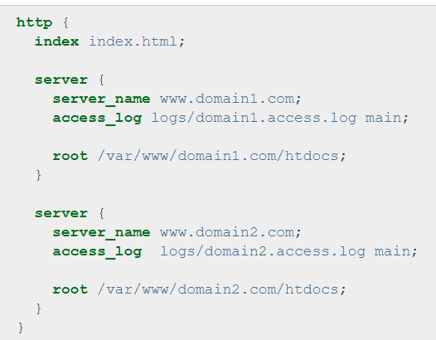

* We just need to add multiple server configuration in nginx conf file as above.
* Each server should listen to different port.

